**HTML ASSIGNMENT**

1.Write html code for the following

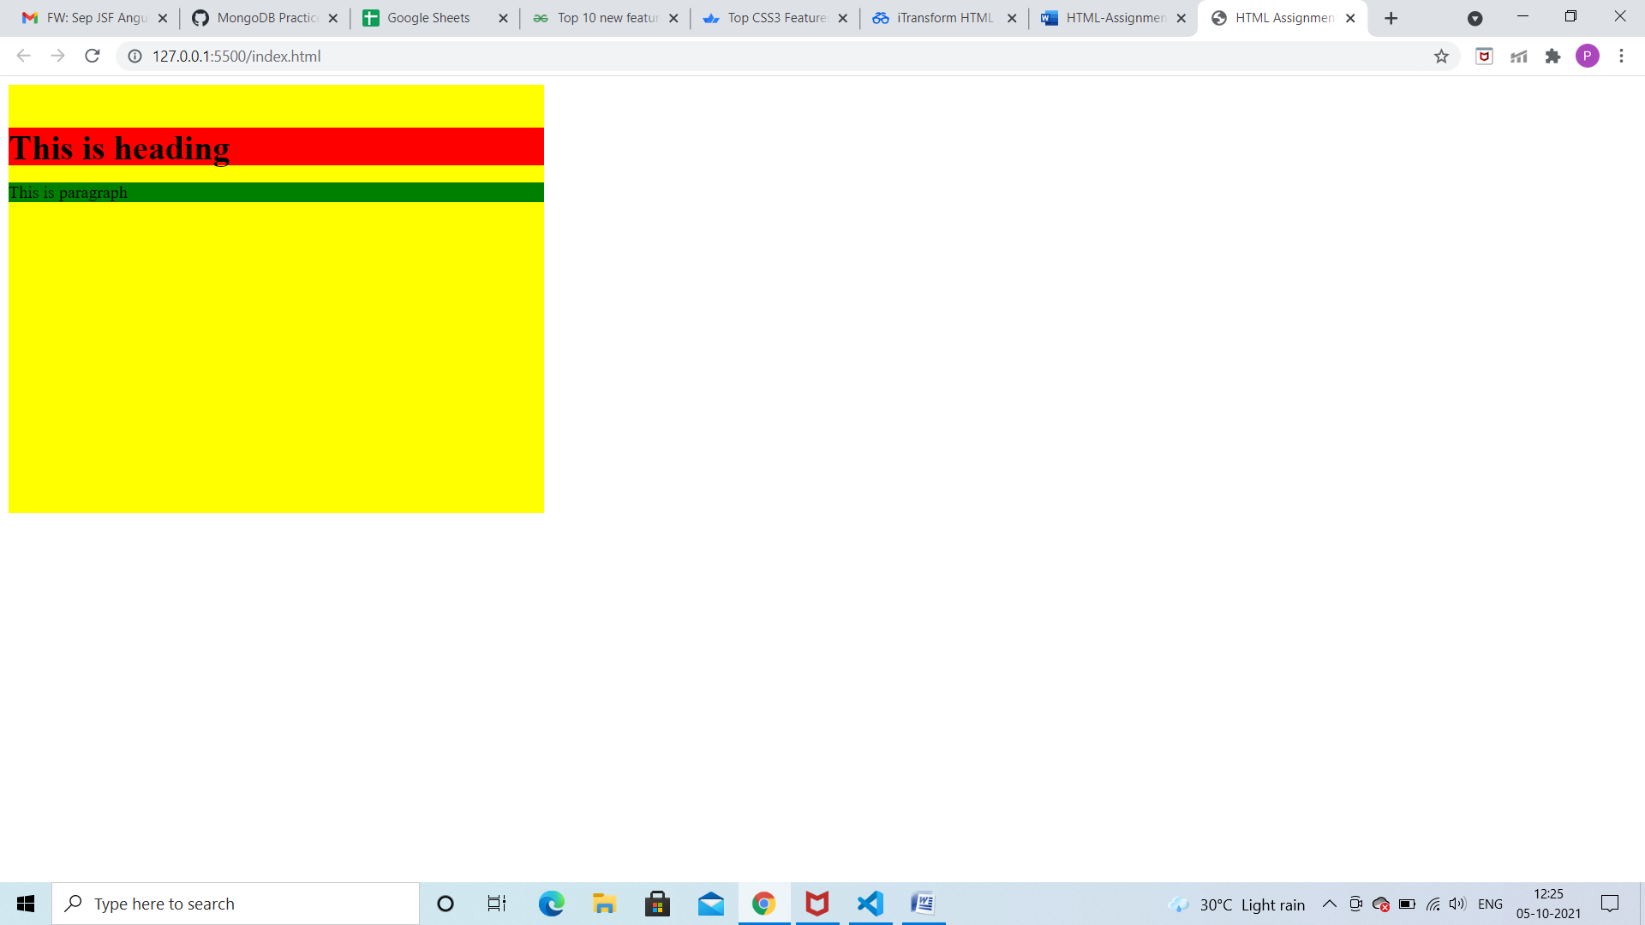

Ans. !DOCTYPE html>

<html lang="en">

<head>

  <meta charset="UTF-8">

  <meta http-equiv="X-UA-Compatible" content="IE=edge">

  <meta name="viewport" content="width=device-width, initial-scale=1.0">

  <title>HTML Assignment</title>

</head>

<body >

  <div style="background-color: yellow;width: 500px;height: 400px;">

    <br>

    <div style="background-color: red;height: 35px;">

      <h1>This is heading</h1>

    </div>

    <div style="background-color: green;">

      <p>This is paragraph</p>

    </div>

  </div>

</body>

</html>

2.Write Html for following text and image below.

Ans. a)The first image has square border

 <a href="hello">

    <img src="images.jfif" style="width:42px;height:42px;border-style: solid;width: 45px;">

    </a>

b)the second image has no border

 <a href="hello">

    <img src="images.jfif" style="width:42px;height:42px">

    </a>

3. Write html for the following text(table)

 <h3>One column:</h3>

 <table>

   <tr>

     <td style="border-style: solid;">100</td>

  </tr>

 </table>

<h3>one row and three columns:</h3>

 <table>

   <tr>

     <td style="border-style: solid;">100</td>

     <td style="border-style: solid;">200</td>

     <td style="border-style: solid;">300</td>

   </tr>

 </table>

 <h3>Two rows and three columns:</h3>

 <table>

   <tr>

     <td style="border-style: solid;">100</td>

     <td style="border-style: solid;">200</td>

     <td style="border-style: solid;">300</td>

   </tr>

   <tr>

    <td style="border-style: solid;">400</td>

    <td style="border-style: solid;">500</td>

    <td style="border-style: solid;">600</td>

  </tr>

 </table>

4.Write html for the following:

a)table has borders

<h3>Two rows and three columns:</h3>

 <table>

   <tr>

     <td style="border-style: solid;">100</td>

     <td style="border-style: solid;">200</td>

     <td style="border-style: solid;">300</td>

   </tr>

   <tr>

    <td style="border-style: solid;">400</td>

    <td style="border-style: solid;">500</td>

    <td style="border-style: solid;">600</td>

  </tr>

 </table>

b)table has no borders

<h3>Two rows and three columns:</h3>

 <table>

   <tr>

     <td>100</td>

     <td>200</td>

     <td>300</td>

   </tr>

   <tr>

    <td>400</td>

    <td>500</td>

    <td>600</td>

  </tr>

 </table>

5.Write html code for the following:

<h3>Numbered list</h3>

    <ol>

      <li>Apples</li>

      <li>Bananas</li>

      <li>Lemons</li>

      <li>Oranges</li>

    </ol>

<h3>Letter list</h3>

    <ol type="A">

      <li>Apples</li>

      <li>Bananas</li>

      <li>Lemons</li>

      <li>Oranges</li>

    </ol>

<h3>Lowercase letter list</h3>

    <ol type="a">

      <li>Apples</li>

      <li>Bananas</li>

      <li>Lemons</li>

      <li>Oranges</li>

    </ol>

<h3>Lowercase roman number list</h3>

    <ol type="i">

      <li>Apples</li>

      <li>Bananas</li>

      <li>Lemons</li>

      <li>Oranges</li>

    </ol>

<h3>Roman number list</h3>

    <ol type="I">

      <li>Apples</li>

      <li>Bananas</li>

      <li>Lemons</li>

      <li>Oranges</li>

    </ol>

6. Write html for the following(password and username)

Ans. <label for="Username">Username:</label>

<input type="text" id="Username">

<br>

<label for="password">Password:</label>

<input type="password" id="password">

7. Write html for the following(radio and submit button)

Ans. <input type="radio" id="bike" name="vehicle" value="bike">

<label for="bike">I have a bike</label>

<br>

<input type="radio" id="car" name="vehicle" value="car">

<label for="car">I have a car</label>

<br>

<br>

<input type="submit" value="submit">

8.Create table

Ans. <div>

  <table style="border-collapse: collapse;width: 150px;" >

    <tr>

      <th colspan="2" style="border: 1px solid black;text-align: left;background-color: turquoise;">Top</th>

  </tr>

  <tr>

      <td style="border: 1px solid black;background-color: gray;height: 40px;">left</td>

      <td style="border: 1px solid black;background-color:lightgrey;height: 40px;">rigth</td>

  </tr>

  </table>

</div>

9.create table with two rows and two columns.

Ans. <div>

  <table style="border-collapse: collapse;width: 150px;" >

    <tr>

      <td style="border: 1px solid black;background-color:lightgrey;">Topleft</td>

      <td style="border: 1px solid black;background-color: gray;height;">Topright</td>

  </tr>

  <tr>

      <td style="border: 1px solid black;background-color: gray;height: 40px;">botleft</td>

      <td style="border: 1px solid black;background-color:lightgrey;height: 40px;">botrigth</td>

  </tr>

  </table>